Talha Khan
IT-481-DL1
4/6/2026

Assignment: Lab 10 – Monitoring & Detecting security issues using AWS config

Step 1: In the AWS console search bar, I typed “AWS Config” and clicked on “CloudTrail – Track Resource Inventory and Changes” and clicked “Get Started”. 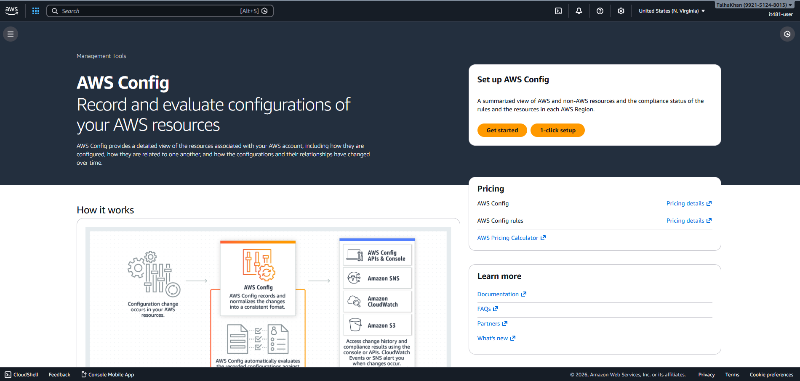

Step 2: Then, I configured the following:
- Recording Strategy: All resource types
- Recording frequency: Continuous recording
- Include global resources: Enabled 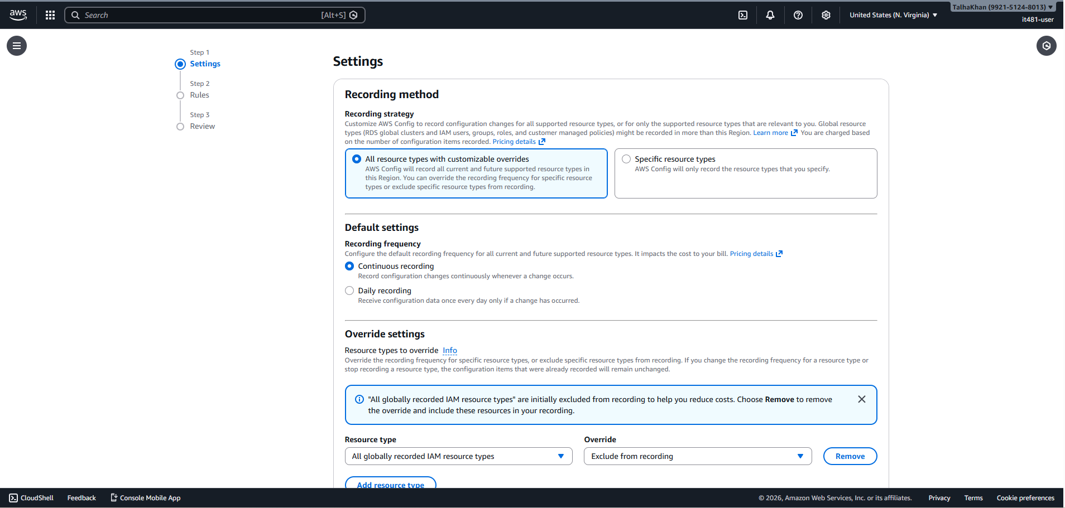
Clicked next and added the rules:
- S3-bucket-public-read-prohibited
- Restricted-ssh 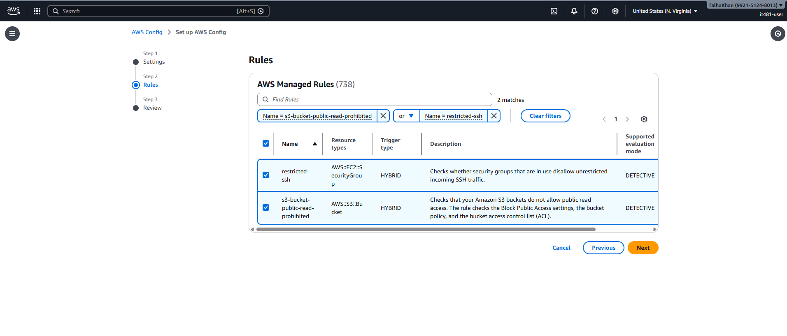

Step 3: Then, I clicked Confirm and waited for a few minutes before navigating to “resources” to verify resources such as EC2 and S3 buckets are listed. 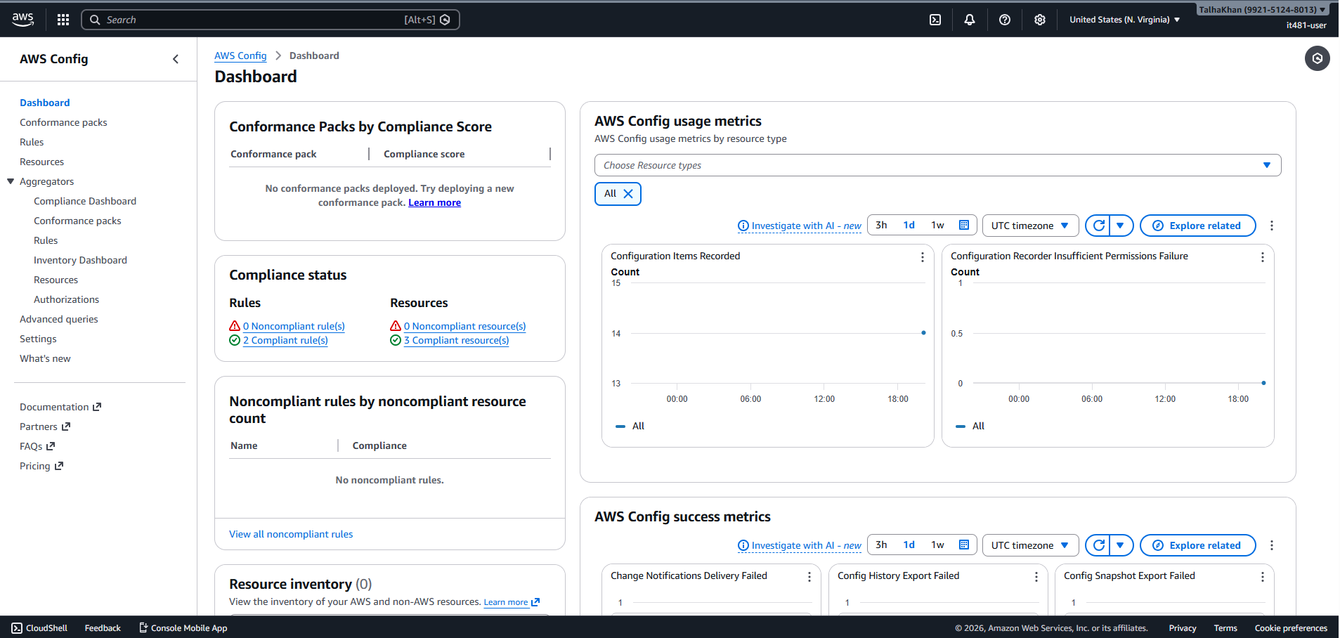
Step 4: Then, I created S3 bucket and headed to Permissions and unchecked “Block all public access” and pasted the following bucket policy:
{
"Version": "2012-10-17",
"Statement": [
{
"Sid": "PublicReadForLab",
"Effect": "Allow",
"Principal": "*",
"Action": "s3:GetObject",
"Resource": "arn:aws:s3:::YOUR_BUCKET_NAME/*"
}
]
} 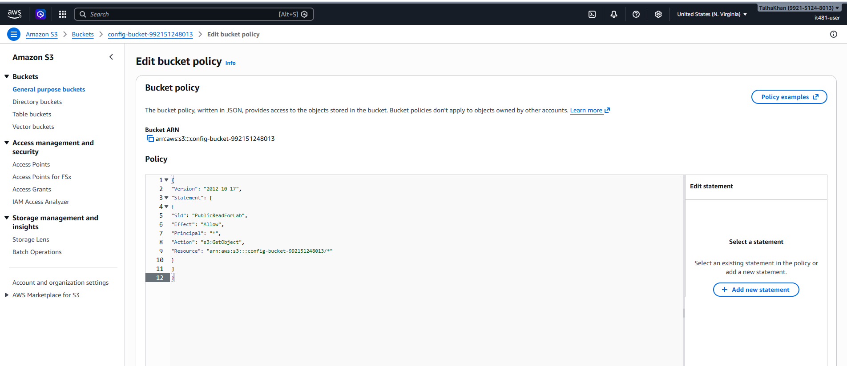
Step 5: I returned to rules in AWS Config and clicked on S3-bucket-public-read-prohibited. Then I clicked on “re-evaluate” in the actions dropdown and observed the rule status as Non-compliant and clicked the affected S3 bucket to view details. 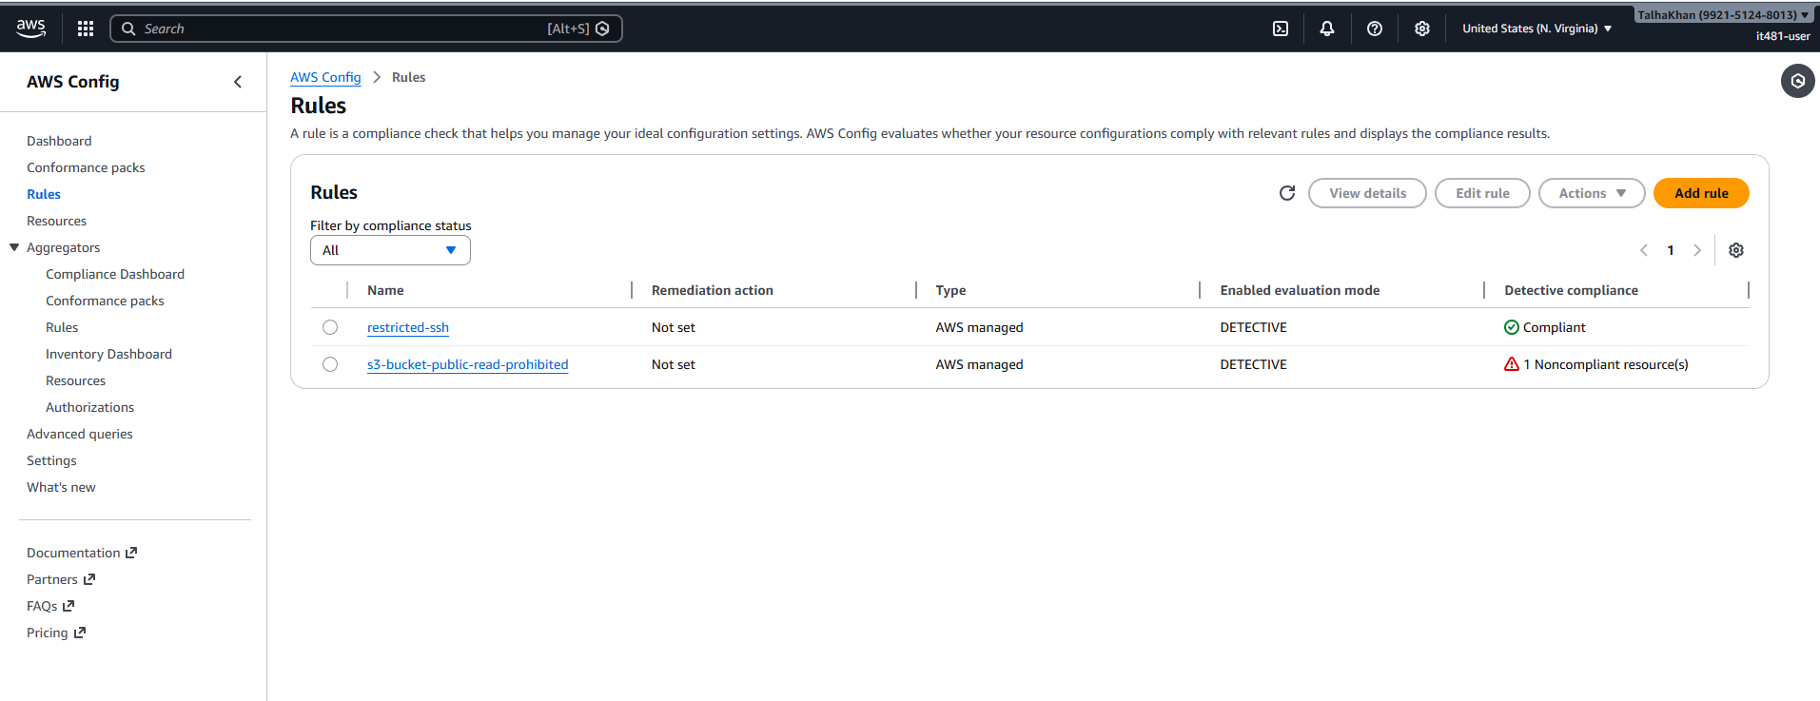 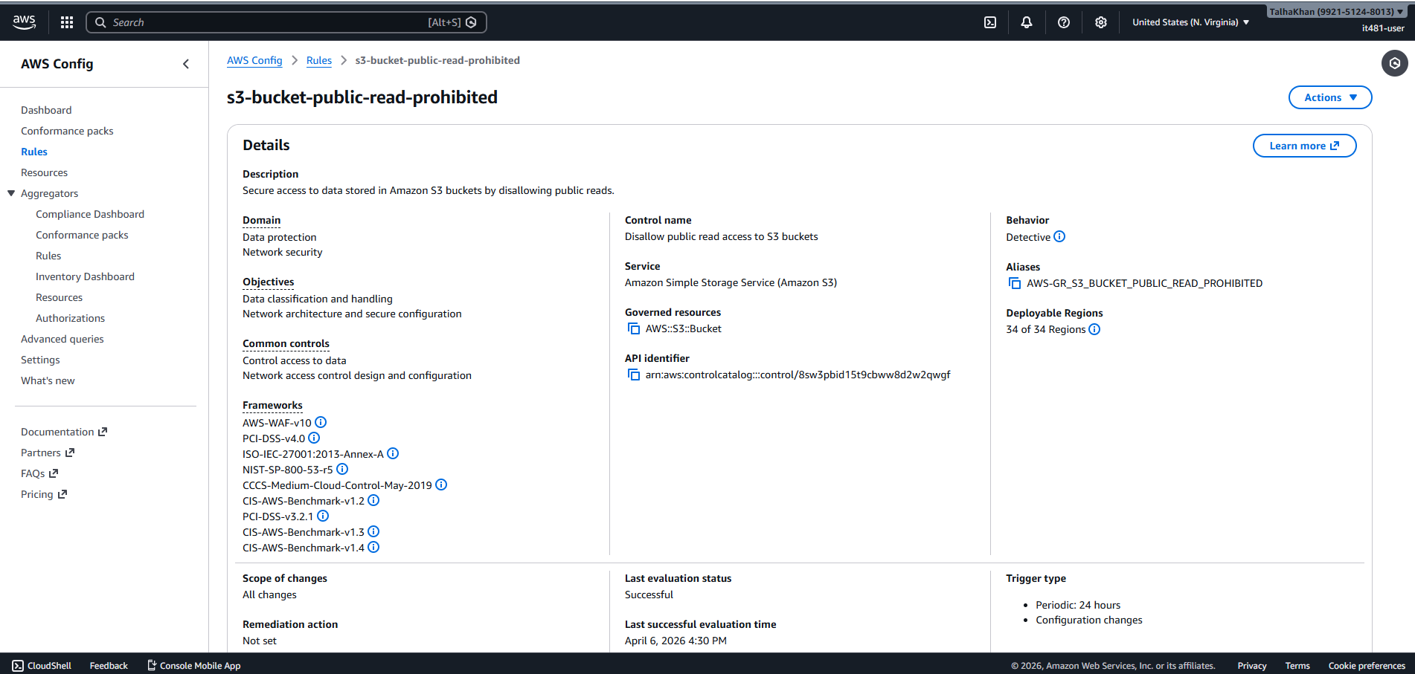
Step 6: Next, I deleted the bucket policy to change the status back to compliant again. 